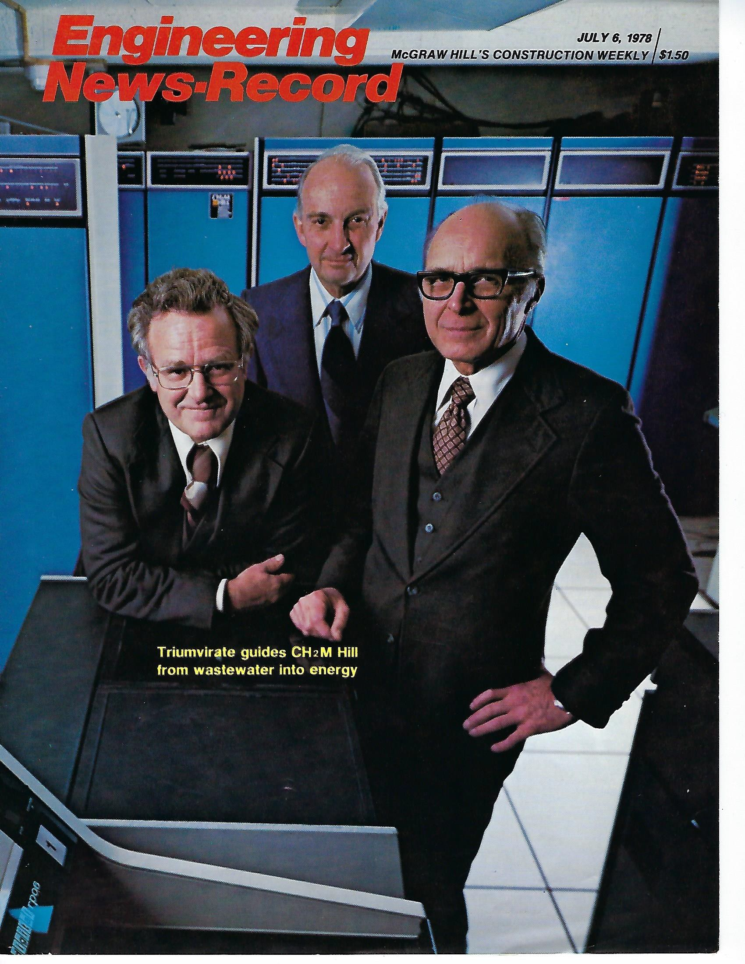

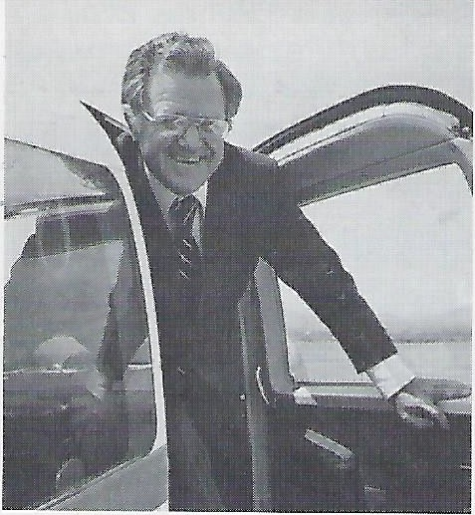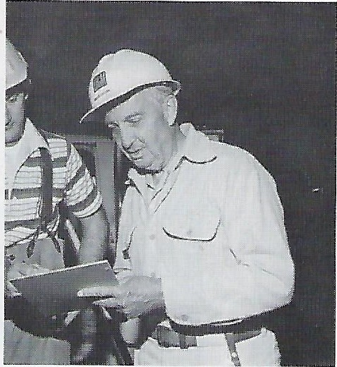

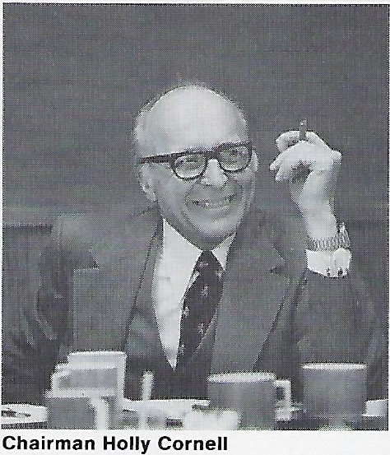
President Harlan Moyer

Operating head keeps company plane busy. Concentrates on planning and development.
Former chief James Howland

Back in the field after 34 years in charge.

CH2M Hill moves from sewage into energy

Consultant CH2M Hill' s new president, Harlan E. Moyer, sees a recent prize his firm won for preliminary design of a manure-to-methane plant as auguring the same kind of growth in that field as it did in another field when the firm won the same award 10 years ago for an advanced wastewater treatment plant.
The Corvallis, Ore., firm had a gross income of only $5 million and a payroll of several hundred when it won its first Grand Conceptor award from the Ameri­ can Consulting Engineers Council (ACEC). That was for the Lake Tahoe wastewater reclamation plant, then called by the U.S. Public Health Service "the most advanced sewage treatment system in the world" (ENR 8/5/65 p. 37).
Moyer was a project manager on the job for Clair A. Hill & Associates, Redding, Calif., which designed the plant in joint venture with Cornell, Howland, Hayes & Merryfield (CH2M). The two firms merged in 1970.
With its la test ACEC citation in hand for the bio-gas plant, CH2M Hill has climbed in annual volume to over $50 million. This ranks it 10th on ENR's list of top designers. It now has a staff of more than 1,400 in 21 regional and 12 project offices. And, says Moyer, who became operating chief earlier this year, " We see energy and energy-related fields as offer­ ink the same opportunities in the next decade that wastewater treatment began to offer in the last decade."
The bio-gas plant for Lamar, Colo., is not the firm's first energy project, but probably is its most innovative. The plant will process manure from 50,000 feedlot cattle, producing 1 million cu ft per day of methane. This will replace half the natural gas fuel for the town's power­ plant. Waste solids will be sold as fertilizer or cattle feed supplement. Process water will be treated and recycled through algae ponds, with algae sold as a protein source. Waste heat from the powerplant will warm the system's anaerobic digesters and the algae ponds.
Also in the energy field, CH2M Hill has assignments to study or design some small hydro plants, cogeneration of electricity and process steam, and coal gasification.
Reaching out. A prime reason for moving into energy, says Moyer, is a desire to escape reliance on public pro jects. He complains of the heavy hand of the federal government, but CH2M Hill officers also cite unusual cooperation with the Environmental Protection Agency (see box). "Only about 25% of our bill­ ings now come from the private sector," says the new president. " We want to increase that to 40% within eight years." CH2M Hill is still known primarily as a designer of major water and wastewater treatment plants in the western U.S. and Canada. But at the beginning of last year it extended its presence by acquiring Black, Crow and Eidsness, Gainesville, Fla., which has offices in the Southeast and Philadelphia. The parent firm also has four foreign offices, in Iran, Egypt,
Saudi Arabia and Trinidad.
Of its total billings of $50 .6 million last

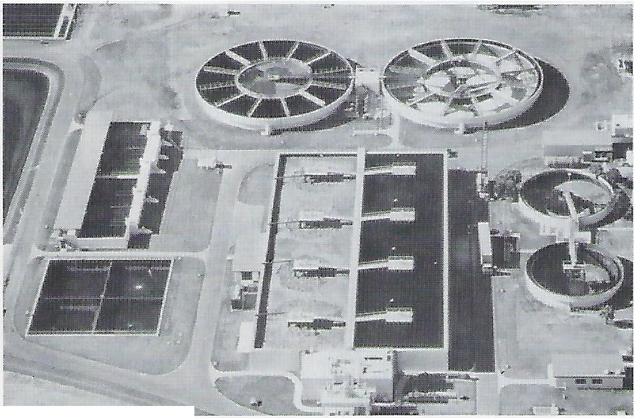Re printed from Engineering News-Record, July 6, 197 8 Copyright © 1978 by McGraw-Hill
---
Advanced sewage plants still are the firm's major business as it reaches out.

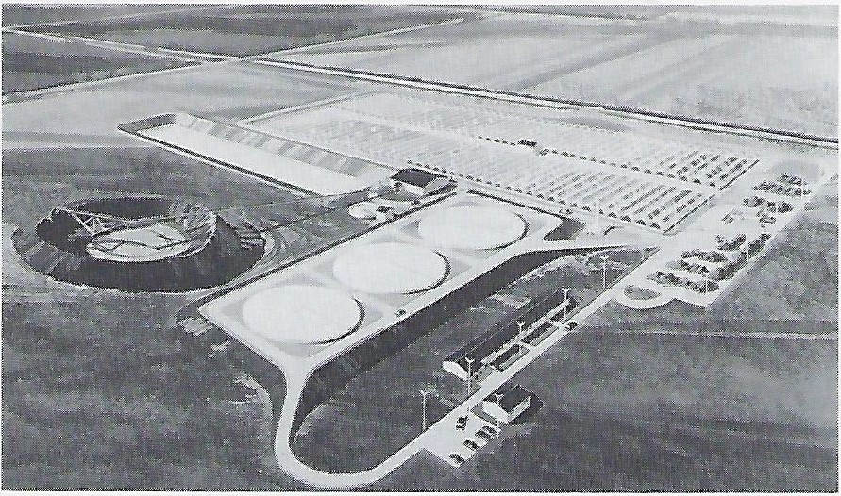
Bio-gas conversion plant will extract methane and other products from manure.
ment oriented than his people-oriented predecessor. He introduced a computer­ ized project management system, built up the business development staff, and added market research and formal planning.
After an internal search for the next president, the board of directors selected Moyer, a 51-year-old civil engineer. He had been vice president and manager of the Redding; regional office since 197 4, as well as south west district manager. Moyer says he will step down in five to seven years and go back to a project.
That is made possible partly by CH2M Hill's rather unusual employee owner ship program. The 190,000 outstanding shares of stock are held by more than 200 key employees. They must sell the stock at the age of 65 but may continue to

year ($8 million accounted for by Black,
Crow), only $1.5 million was from foreign work. But that may change. One major new job is as prime consultant on a
$ 7.5-million contract with Saudi Arabia to prepare a regional development plan and three city master plans for the Damman area on the Persian Gulf.
The firm already offers a complete range of planning and design services, except architectural. And, while energy is its major new thrust into the private market, Moyer also expects increased volume in designing food processing and other industrial plants, complete with
that up and turn the reins over to a new
group was a pretty-good-sized bump in the road. That's when we decided to have Holly serve as a kind of ramp to get from where we were to where we are going."
Cornell, who is 63, proved an effective ramp. While billings eased a bit to $30 million in 1976, they climbed by two thirds the following year to a record (including Black, Crow’s contribution). "We reaped the benefits of a business development plan for which we desig­ nated up to 10 % of anticipated revenues," says Cornell, who is called more manage-
work. Howland and Cornell still hold 14,000 shares each, but in the future, no one will be permitted to own more than 5% of the shares outstanding.
Some older principals feel their hold­ ings would be more valuable if ownership were limited. The genial Howland disputes that: " We'd be a smaller company today if we hadn't been able to maintain a reservoir of outstanding engineering talent. If we had kept everything to ourselves, there 'd be no one to take our places and we probably would have sold out to a larger firm."

waste treatment facilities. He also sees
agricultural engineering and construction

management as growth areas.
Management shift. The selection of
CM and value engineering broaden opportunities

Moyer as president symbolizes the shift in direction. He is only the third president in the 33-year history of the original CH2M company since it was organized by "three boys and prof" at Oregon State University, and the first who is not a founding partner.
James C. Howland served 30 years as president and three as chairman. In an un usual move, he stepped down at the age of 61 and became the firm's program director for a $230-million secondary treatment project at San Diego. Holly Cornell, described as "transitional" president for three years and now chairman, has divorced himself from day to day operations and directs planning and busi­ ness development. Burke Hayes retired early this year but continues as a consul­ tant. Prof. Fred Merryfield retired eight years ago and died last year.
"We began planning for a change in leadership when Jim [Howland] an­ nounced he was stepping down as presi­ dent," recalls Hayes. "We had run the firm like a family for 30 years with Jim
Construction management and value engi­ neering are among the newer services adding to CH2M Hill's billings. And the firm is pioneering in applying them on projects funded under the Environmental Protection Agency's (EPA) construction grants program.
CH2M Hill was consultant on the $21- million Rock Creek advanced wastewater treatment plant near Hillsboro, Ore., the first EPA-funded project built under a construction management system (ENR 12/23/76 p. 47). CM slashed the construction time by one-fifth and cut the cost by 16%. Construction of the fast-tracked project began while design was still in progress, allowing earlier orders for equipment and permitting the project to be broken into smaller bid packages to increase competition.
The 15-mgd regional plant was completed in 33 months under three major contracts, but a total of 50 separate contracts were let. That increased the paperwork and the requirement to coordinate with the EPA regional office in Seattle immensely. But the firm's CM director, Harr y C. Teel, says, "We kept them involved and they kept their promises in meeting dead­ lines for plan review and other decisions. Our longest wait on plan review was only two weeks." Top EPA officials credit their Seattle
office with being unusually progressive and responsive. CH2M Hill executives agree.
With EPA now actively trying to introduce CM, the design firm has management contracts on a $45-million project at Bend, Ore., and a smaller one for Nampa, Idaho. Those are dwarfed, however, by the firm's assignment as prime consultant on Milwaukee's $1.4-billion water pollution abatement program, where its staff of 35 to 40 will provide some CM services during the 10-year program.
When Holly Cornell was president of CH2M Hill, he recognized that the recent EPA requirement for value engineering on projects costing over $10 million also presents a good business opportunity. "We've always done some value engineering,” he points out, “but we formalized our procedures under EPA."
On a $90-million sewage treatment plant and outfall for the East Bay Dischargers Authority at Hayward, Calif., the firm achieved a benefit-cost ratio of 26:1, based on its VE fee. It recommended life cycle cost savings that totaled $34.6 million and the client implemented project changes that cut the initial cost by $7.2 million.
Cornell sees VE as still "a coming field," though he doubts that it will ever represent more than 5% of the firm 's volume.

as general manager. To suddenly break

